**LAB#07(a)**

# Static Routing

To Configuring Static Routing.

**Theory:**

**Static Routing:**

Static routing is a method of entering routes into the device’s routing table stored in a configuration file manually which is loaded when the Cisco router starts up. These routes can be configured manually by network administrators.

**Advantages:**

Static routing has the following advantages:

* There is no overhead on the router CPU.
* There is no bandwidth usage between routers.
* It adds security because the administrator can choose to allow routing access to certain networks only.

**Disadvantages:**

Static routing has the following disadvantages:

* The administrator must really understand the internetwork and how each router is connected in order to configure routes correctly.
* If a network is added to the internetwork, the administrator has to add a route to it on all routers—manually.
* It's not possible in large networks because maintaining it would be a full-time job in itself.

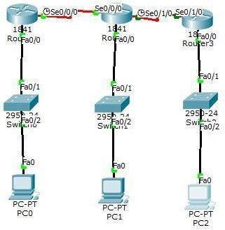

**Procedure:**

**Step1:**

The topology consists of 3 Cisco routers which are connected with each other and also with 3switches and switches are connected with 3PCs **Step 2:**

A WIC-1T card is placed in the slots in each router. Switch off the router and place the card in the slots and turn it on again. One end of the cable is DTE and the other is automatically DCE.

**Step 3:**

We have total 5 networks , now assign ip to each network, assign first three ip in pc using default gateways: 192.168.1.1, 192.168.2.1, 192.168.3.1and remaining two on the serial interface of router. **Step 4:**

Now configure fast Ethernet and serial interface of router by using CLI. Configuration of R0 are as follow:

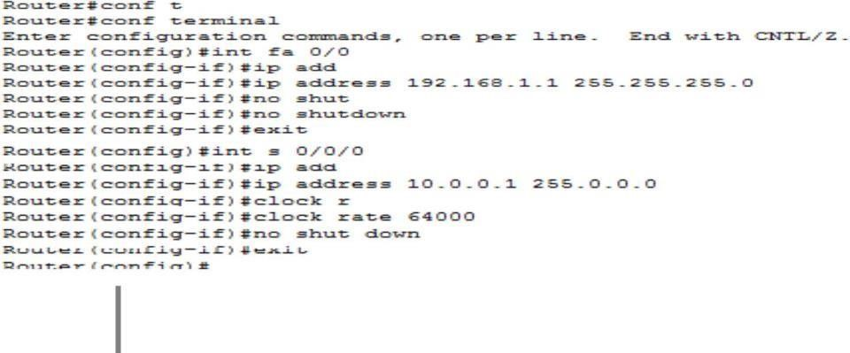

**Step 5:**

**Enabling Static Routing:**

By using following Syntax:

## Destination network address , subnet mask , next Hop

Enable a static routing process, which places you in router configuration mode. And associate the networks with a static routing process. Then enter the command **show ip route** on Ro, R1 and R2 to verify that the new route is now in the routing table.

**Exercises:**

**Q1.** What is static routing what is the use of it?

Static routing can be used to define an exit point from a router when no other routes are available or necessary. This is called a default route. Static routing can be used for small networks that require only one or two routes.

**Q2.** How do we configure static routing?

Navigate to the Configuration > Network > IP > IP Routes page. Click Add to add a static route to a destination network or host. Enter the destination IP address and network mask (255.255. 255.255 for a host route) and the next hop IP address.

Q3. Write the advantages & dis advantages of dynamic routing.

There are disadvantages to dynamic routing. Dynamic routing requires knowledge of additional commands. It is also less secure than static routing because the interfaces identified by the routing protocol send routing updates out. Routes taken may differ between packets.

The chief advantages of dynamic routing over static routing are scalability and adaptability. A dynamically routed network can grow more quickly and larger, and is able to adapt to changes in the network topology brought about by this growth or by the failure of one or more network components.

**Q.4.** Write the advantages & dis advantages of Static routing.

Advantages of static routing are Static routing consumes less bandwidth when compared to dynamic routing as no CPU cycles are-used in route calculation and communication. Because static routes do not advertise their route over the network, it results in better network security.

The disadvantages are They are not easy to implement in a large network. Managing the static configurations can become time consuming. If a link fails, a static route cannot reroute traffic.

**Q.5.** What is meant by the term Autonomous system?

An Autonomous System (AS) is a set of Internet routable IP prefixes belonging to a network or a collection of networks that are all managed, controlled and supervised by a single entity or organization. An AS utilizes a common routing policy controlled by the entity.

**Q.6.**How do you display the contents of a Cisco IP routing table?

Use the show ip route EXEC command to display the current state of the routing table.

**LAB#7 (b)**

# Virtual Local Area Networks

To study about VLAN and their implementation.

**Theory:**

**VLAN:**

VLANs allow network administrators to [partition t](http://searchstorage.techtarget.com/definition/partition)heir networks to match the functional and security requirements of their systems without having to run new cables or make major changes in their current network infrastructure.

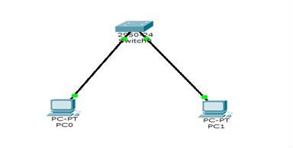

Firstly assign IP to pc then ping it both pc are successfully connected to switch.

**Step #1:**

For creating VLAN 2 on PC0 and vlan3 on PC1 first assign name to VLAN on switch CLI by using following commands.

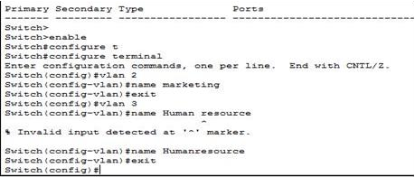

**Step #2:**

After assigning name to VLAN write the following commands for activating VLAN

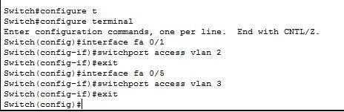

VLAN has created pass the message and observed the result.

**EXERCISES:**

Q.1) After ping command what message you received and why?

When you ping a device you send that device a short message, which it then sends back (the echo). If you receive a reply then the device is working OK , if you don't then: The device is faulty, disconnected, switched off, incorrectly configured. Your network or the device you are working on is not working properly.

Q.2) Advantage of vlan?

VLAN allows you to add an additional layer of security. It can make device management simple and easier. You can make a logical grouping of devices by function rather than location. It allows you to create groups of logically connected devices that act like they are on their own network.

Q.3) What is the purpose of ping command?

A ping is used to verify connectivity at an IP-level to a second TCP/IP device. It does this by transmitting Internet Control Message Protocol (ICMP) Echo Request messages and waits for a return message. Unless modified, the ping command will send 4 requests by default in Windows.